

**REGISTRATION APPLICATION**  
**Register for applicants**

Please return the completed and signed form to:

FROHME

**C.P. 28**

**Mercier (Québec) J6R 2K6**

Email: [info@frohme.org](mailto:info@frohme.org)

**Note: For ease of reading, the abbreviation Fédération régionale des OSBL d'habitation de la Montérégie et de l'Estrie - FROHME- will be used. For the same purpose, the masculine gender will be used.**

**INTRODUCTION**

You are applying for housing in community housing where people live who are both tenants of their units and collectively responsible for their buildings. It is communally owned. The tenants must participate in the management and maintenance of the organization to reduce operating costs and jointly manage their dwelling according to their cap abilities and availability.

If you are interested in the challenge of living in community and getting involved in the management and maintenance of our buildings, we invite you to fill out this application. Please note that a minimum of three (3) hours of involvement per month is mandatory and will be listed as a condition on your lease, except for certain buildings for seniors.

**STEPS TO SUBMIT YOUR APPLICATION**

c ❷ INCLUDE THE FOLLOWING PROOF OF INCOME WITH YOUR APPLICATION

Detailed previous year's provincial notice of assessment

A photocopy of this document must be provided for each person 18 years of age or older listed on the application.

▪ Please note that no photocopies can be made on site. No original document can be returned to the sender or picked up on site.

▪ Please be advised that additional photocopies of documents such as birth certificates, child custody judgments, leases, other proof of income, etc., will be requested when housing that corresponds to your search criteria and allocation standards becomes available. So, take your advances and have them ready.

Translated with www.DeepL.com/Translator (free version)

**CHECK YOUR ELIGIBILITY FOR MOBILE RENTAL ACCOMMODATION (GRANTED)**

**❶**

|  |  |
| --- | --- |
| Yes r No r | You are a Canadian Citizen or Permanent Resident |
| Yes r No r | You resided in Quebec (or for certain organizations in the Montreal Metropolitan Community) for a minimum of 1 year during last 24 months. |
| Yes r No r | You are not a full-time student without dependents. |

Ensure that the gross income of all persons aged 18 and over listed on the application (line 199 of the Provincial Notice of Assessment) does not exceed the following amounts. **Note that these amounts are reviewed annually and may vary from year to year.**

***Beauharnois ▪ Châteauguay ▪ Mercier******▪ La Prairie ▪ Pointe-des-Cascades Saint-Amable ▪ Saint-Constant***

***▪ Saint-Jean-sur-Richelieu ▪ Sainte-Julie ▪ Saint-Philippe ▪ Varennes***

|  |  |  |  |
| --- | --- | --- | --- |
| Couple or  1 person | 2 or 3 people  (non couple) | 4 or 5 people | 6 or 7 people |
| **44 000,00 $** | **47 000,00 $** | **65 500,00 $** | **82 000,00 $** |

***Howick ▪ Rougemont ▪ Sainte-Justine-de-Newton ▪ Roxton Falls ▪ Sainte-Martine ▪ Saint-Rémi***

|  |  |  |  |
| --- | --- | --- | --- |
| Couple or  1 person | 2 or 3 people  (non couple) | 4 or 5 people | 6 or 7 people |
| **28 000,00 $** | **36 000,00$** | **40 000,00$** | **44 000,00$** |

Depending on the specifics of the organizations for which you are applying, other eligibility criteria, such as your age or level of independence, may apply.   
 Initials: __________

**YOU ARE NOT ELIGIBLE IF:**

* You or another member of your household are a former tenant of a low-rent (subsidized) unit whose lease has been terminated due to a loss of ownership, non-payment of rent or following another type of decision by the *Tribunal administrative du logement*. This ineligibility is for a period of 5 years from the date of the decision.
* You or another member of your household have a debt towards a low-come (subsidized) property owner.

**INCLUDE THE FOLLOWING PROOF OF INCOME WITH YOUR APPLICATION**

❷

**Detailed previous year's provincial notice of assessment**

A photocopy of this document must be provided for any person who 18 years of age or older listed on the application.

Note that no photocopies will be made on site. No original document can be returned to the sender or picked up on site.

Please be advised that additional photocopies of documents such as birth certificates, child custody judgments, lease, other proof of income, etc., will be requested when a dwelling that meets your search criteria and is available. So, take your advances and have them ready.

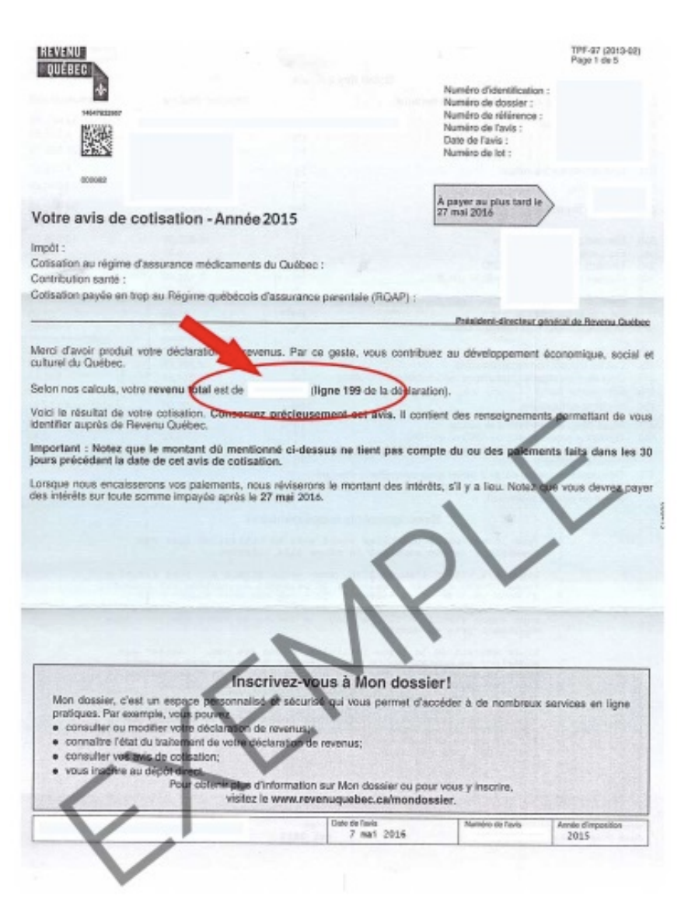

**SEND US YOUR REQUEST**

❸

**By mail:** FROHME C.P. 28. Mercier (Québec) J6R 2K6

**By email:** [info@frohm.org](mailto:info@frohm.org)

Do not forget to initialize all pages of the application form and sign the last page.

**IMPORTANT INFORMATION TO READ BEFORE COMPLETING THE FORM**

* To ensure the progress of your file, it is essential to provide written updates every year or when there are changes in the composition of your household (birth, death). You must also write us any changes to the eligibility criteria as well as a change of address or telephone number.
* Your application may be considered a priority if you provide supporting documentation from recognized authorities that demonstrates one of the following situations: domestic violence, unsafe or unsuitable housing, affected or expropriated housing.
* Please note that due to a significant reduction in FROHME funding, support for applicants is suspended. As a result, we are no longer able to provide this service to housing applicants. Following the filing of your application, you will receive a written response within the time limits set out in the Regulation.
* **Your application is valid for twelve (12) months from the date of receipt. You must send us your new notice of assessment before September 1 of the year following the filing of your application. Once this deadline has expired, if you need housing, you must reapply.**

Please note that the housing application form is also available on the FROHME website: [https://frohme.org](https://frohme.org/)

Initials: __________

|  |  |  |  |  |  |  |  |  |
| --- | --- | --- | --- | --- | --- | --- | --- | --- |
| **PRIMARY APPLICANT** | | | | | | | | |
| First and last name : |  |  | | | | | | |
| Phone number: |  |  |  | Date of birth (YY/MM/ DD): |  |  |  |  |
| Other phone number: |  |  |  | Ciivl status: |  | | | |
| Email: |  |  |  | Gender: | M / F / Other (circle) | | | |

|  |  |  |  |  |  |  |  |  |
| --- | --- | --- | --- | --- | --- | --- | --- | --- |
| **LIVING ADDRESS** | | | | | | | | |
|  |  |  |  |  |  |  |  |  |
| No |  | Street |  | App. |  | City |  | Postal Code |

|  |  |  |  |  |  |  |  |  |  |  |  |
| --- | --- | --- | --- | --- | --- | --- | --- | --- | --- | --- | --- |
| How long have you lived at this address (Y/M): | | | | | | | | |  |  | |
|  | | | | | | | | |  |  | |  | |  |  |
| **Previous addresses** (fill in if you have lived at your actual address for less then 2 years) | | | | | | | | | | | | | | | | | | |
|  |  |  |  |  |  |  |  |  | | |  | | _______ | | | |  | _______ |
| No |  | Street |  | App. |  | City |  | Postal Code | | |  | | From YY/MM | | | | to | YY/MM |  | MM |
|  |  |  |  |  |  |  |  |  | | |  | | _______ | | | |  | _______ |  |  |
| No |  | Street |  | App. |  | City |  | Postal Code | | |  | | From YY/MM | | | | to | YY/MM |  |  |

|  |  |  |  |  |  |  |  |  |  |  |  |
| --- | --- | --- | --- | --- | --- | --- | --- | --- | --- | --- | --- |
| **HOUSEHOLD COMPOSITION (list all the people who will be living with you)** | | | | | | | | | | | |
| First and last name of spouse (if applicable) | | | |  | | | | Gender: M / F / Other (circle) | | | |  | | |
| Phone Number : | |  | | | Date of Birth (YY/MM/DD) : | | | |  |  |  | |
| Other people who will be living with you: | | | | | |  | |  |  |  |  | | |
| First and Last name | Annual Income | | Birth Date  Y/ M/ D | | Gender  (M/F/O) | | Full time Student | Shared Custody  (%) | Relationship to  the applicant | | |
|  |  | |  | |  | |  |  |  | | |
|  |  | |  | |  | |  |  |  | | |
|  |  | |  | |  | |  |  |  | | |
|  |  | |  | |  | |  |  |  | | |
|  |  | |  | |  | |  |  |  | | |
| **The only relatives admissible are: daughter/son, brother/sister, mother/father, caregiver.** | | | | | | | | | | | |
| **PETS** | | | | | | | | | | | |

|  |  |  |  |  |
| --- | --- | --- | --- | --- |
| Do you have pets? | r Yes r No | How much? _________ | | What type (breed)? _____________ |
| If it's a dog, what's its weight? ______ | |  |
| In most organisms, dogs are not allowed, in others, no animals are allowed. | | | | | |  | |
| Would you be willing to give up your animals? | | | r Yes r No | |  | |  | |  |

Initials: __________

|  |  |  |  |  |  |  |  |
| --- | --- | --- | --- | --- | --- | --- | --- |
| **SECTOR CHOICE (check one or more organizations)** | | | | | | | |
| **FAMILIES AND INDIVIDUALS** | | |  | **PEOPLE WITH REDUCED MOBILITY** | | |
| **City** | **Check** | **Organization name** |  | **Резултат с изображение за pictogramme handicap** | | |
| Châteauguay | **r** | Aux Baux Soleil |  |
| Howick | **r** | Vallée des Tisserands |  | **City** | **Check** | **Organization name** | | |
| La Prairie | **r** | La Petite Prairie |  | Saint-Constant | **r** | PAL | | |
| Mercier | **r** | Philomène |  | Saint-Jean-sur-Richelieu | **r** | Handi-Logement | | |
|  | **r** | Sambault |  |  |  |  | | |
| Saint-Constant | **r** | Logis-Ciel |  | **PEOPLE AGED 65 AND OVER** | | |
|  | **r** | Trilogis |  | **City** | **Check** | **Organization name** | | |
| Sainte-Martine | **r** | Vallée des Tisserands |  | Châteauguay | **r** | Manoir P. Lanctôt | | |
| Saint-Philippe | **r** | La Gaillarde |  | La Prairie | **r** | Balmoral | | |
| Saint-Rémi | **r** | La Rémoise |  |  | **r** | HVLP | | |
|  |  |  |  | Saint-Amable | **r** | Habitations St-Amable | | |
|  |  |  |  | Saint-Constant | **r** | Trilogis | | |
| **PEOPLE AGED 55 AND OVER** | | |  | Saint-Philippe | **r** | La Gaillarde | | |
| **City** | **Check** | **Organization name** |  | Saint- Rémi | **r** | La Rémoise | | |
| Beauharnois | **r** | Auguste-Hébert |  |
| Rougemont | **r** | Villa Rougemont |  |
| Roxton Falls | **r** | Manoir des 1000 fleurs |  |
| Sainte-Julie | **r** | Villa de l’amitié |  |
| Sainte-Justine-de-Newton | **r** | CLOD |  |
| Varennes | **r** | Manoir de Varennes |  |
| Pointe-des-Cascades | **r** | Société d’habitation Pointe-des-Cascades |  |

|  |  |  |  |  |  |  |  |  |  |  |  |  |  |  |  |  |  |  |  |  |  |  |  |  |
| --- | --- | --- | --- | --- | --- | --- | --- | --- | --- | --- | --- | --- | --- | --- | --- | --- | --- | --- | --- | --- | --- | --- | --- | --- |
| |  |  | | --- | --- | | **APPLICANT DECLARATION (please check)** | | |  |  | | **r** | I certify that the information provided is true and complete. I authorize FROHME to share this information with community housing managers for rental purposes only. | | **r** | I acknowledge that any false or incomplete statements on this form or any other document attached to my application may result in my application being cancelled or my application being removed from the application register, the eligibility list or the withdrawal of a housing offer. | | **r** | I agree that the information provided may be used by the *Comité logement* and the *GRT Rive-Sud* for their statistics for the exclusive purpose of developing community housing projects. | | **r** | **I understand that this application is only valid for a period of twelve (12) months from the date of receipt, that I must re-submit, once the deadline has been renewed, and that, if my application is not renewed, my file will be destroyed.** | | **r** | I understand that this application does not constitute an acceptance and an obligation by an organization to provide me with housing. |  |  |  |  |  |  | | --- | --- | --- | --- | --- | |  |  |  |  |  | | **Signed in** |  | **Date** |  | **Applicant's signature** | |